SEND INFORMATION
Our Vision

“All children and young people at St Mary’s Catholic Primary School with SEND have access to high quality local provision that meets their needs.”

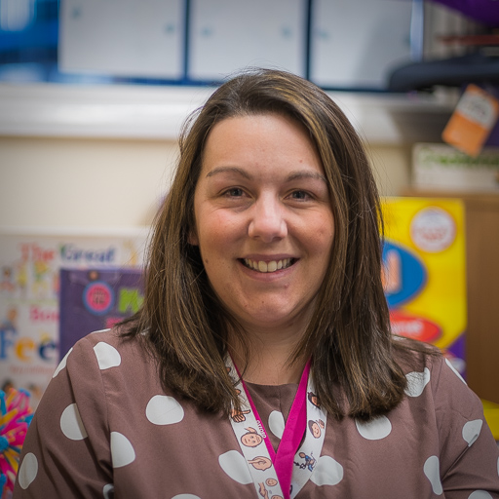

Mrs Karen Driver
SENCo & Safeguarding Lead

Mrs Karen Driver is our Special Education Co-ordinator and a Safeguarding Lead for St Mary’s Catholic Primary School. Mrs Driver works alongside teachers, parents and external agencies to ensure pupils with special educational needs have the provision they need to succeed.

Children with SEND needs are monitored by termly targets through an individual Pupil Profile Plan. Those children whose needs exceed the universal offer may require an Educational, Health and Care Plan [EHCP], this is reviewed annually by teachers, parents and external agencies.

At St Mary’s Catholic Primary School we work closely with the following agencies:

- SENSS Communication & Interaction Team
- SENSS Speech & Language Team
- SENSS Deaf & Hearing Support Team
- Education Behaviour Support Team
- Educational Psychologist
- School Nurse Team
- CAMHS - Children & Adolescent Mental Health Service
- MHST - Mental Health Support Team
- LCSS - Locality Community Support Service
- Community Paediatrician
- General Practitioners
- Early Years SEN Support Team
- SAFE!
- Building Respectful Families
- Clear Sky Play Therapy
- Chiltern Music Therapy
- Occupational Therapy

St Mary’s Catholic Primary School is part of Bicester Learning in Partnership (BLIP) of which encompasses a group of local primary and secondary schools, working together to improve provision for children with SEND.

Contact our SENCo:
Please email or phone our school office to speak with Mrs Driver.

Email: office.3824@st-marys-bicester.oxon.sch.uk Telephone: 01869 252 035

Important SEND Information
Local Offer
As of the SEND reforms, Oxfordshire County Council is to provide detailed information on available support and provision for children and young people (0-25) with SEND needs.

The purpose of the local offer is to enable parents and young people to see more clearly what services are available in their area and how to access them. It includes provision from birth to 25, across education, health and social care.

Link to Local Offer - https://www.oxfordshire.gov.uk/residents/children-education-and-families/education-and-learning/special-educational-needs-and-disability-local-offer

Sendiass Oxfordshire
Sendiass is a Special Educational Needs and Disability information, advice and support service.
Link to Sendiass - https://sendiass-oxfordshire.org.uk/

